Automated News Article Classification using Linear Support Vector Machines and TF-IDF Vectorization
¹Andrew Looi Szu Kit, ²Khor Ken Joo & ³Eric Lee Shen Yi
^{1&3} School of Computing, Universiti Utara Malaysia, Malaysia
²Faculty of Computer Sciences, University of Sydney, Australia

^{*1}andrew_looi_szu@soc.uum.edu.my
²khor_ken_joo@soc.uum.edu.my
³eric_lee_shen@soc.uum.edu.my
*Corresponding author

Received: 5/5/2025 Revised: 26/6/2025 Accepted: 5/7/2025 Published: 31/7/2025

INTRODUCTION

The news consumption has almost completely moved to online platforms in the modern digital world. This shift has led to an exponential growth in the amount of unstructured text data that is being created daily. To the media aggregators, digital archives, and news organisations, the fact that they can organise, tag, and efficiently access this onslaught of information is vital. Multi-class text classification, also known as the automated classification of news articles into established categories, is the main problem being addressed in this report.

This task is also important in more than mere organisation. Manual classification is resource-consuming, time-consuming, and prone to human error and inconsistency. The problem of information overload is solved with the help of an automated system, which provides indexing in real-time. This makes the process of providing personalised content recommendation systems, which is crucial in user interaction, and enables the analysts to monitor trends in particular areas in real-time. This enables personalised content recommendation systems, which are critical in user engagement, and enables analysts to trace trends in real-time in certain areas. Effective archiving of current news production would be impossible without automation because of the scope of the exercise.

The main technical difficulty consists of the fact that the data is unstructured. News articles have different lengths, convoluted sentence structures, idioms, and noise as opposed to an organized database where there are distinct rows and columns. Moreover, categories are frequently vaguely delineated, as the report about the governmental financing of arts might actually be categorised under Politics and Arts & Culture. This project was aimed at creating a machine learning model that would be able to navigate these linguistic finesse and predict the single most accurate category of a particular text.

BACKGROUND

This project is based on more generalised foundational approaches to Natural Language Processing (NLP) and Supervised Machine Learning in order to address the text classification issue. The most common method is the Term Frequency-Inverse Document Frequency (TF-IDF) vectorisation, which is a successful development of the more classical Bag of Words (BoW) model. The basic assumption of the method is that the subject of a text can be statistically deduced based on the rate of the distinctive words.
Contrary to counting words simply, TF-IDF ranks words based on how frequently they occur; it decreases the score of common words such as “the” or “report” that appear in all the documents, but increases the score of discriminatory words such as impeachment or quarterly earnings that are unique to a particular document.

To model our stage, we chose the Linear Support Vector Classification (Linear SVC) algorithm. In theory, this algorithm works through finding an optimal hyperplane or decision boundary in a high-dimensional space. Linear SVM aims to classify the data points, that is, Politics versus Business, of the different classes that are as distinct as possible and make robust predictions even when the data is sparse.

The domain specificity of news media should also be valued in order to apply such methods to their full extent. News pieces are usually organised into the inverted pyramid, with the most important of all information being summarised in the headline and the first paragraph. The domain knowledge directly explained our preprocessing plan, as we combined the title and the body of the article into one feature. This guarantees that the model captures very lucrative keywords that may be present solely in the headline, which improves the quality of the classification.

THE PROPOSED METHOD

Overview of the Proposed Framework

The goal of this project is to develop a real-time pattern recognition system for text classification. In order to predict categories in a live-stream simulation, the framework is designed to process text data, convert it into numerical features, and then apply a supervised learning algorithm. The three primary stages of the system’s modular architecture are data preprocessing, feature extraction, and model training/evaluation.

Dataset Selection and Preprocessing

The dataset used in the study was a collection of news articles entitled news-article-categories.csv that is formatted into three major columns: category, which serves as the target label, the title representing the headline, and body, which contains the whole text content. The pandas library was used to ensure that the model was clean. The first step in processing was to identify and delete duplicate entries, in order to prevent the possibility of data leakage, an important step that guarantees that the model is not tested on the same data that it saw during training. Moreover, rows with blank values in the title or body column were removed to ensure that there is consistency in the entry to the remaining steps of vectorization.

Figure 1

Data Cleaning
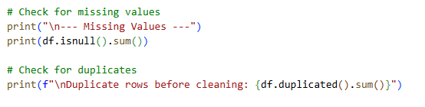
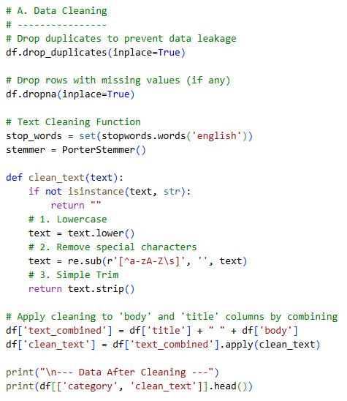

After the initial cleaning, there was a custom text preprocessing function that was used to normalize the linguistic data. Every text was changed into small letters to allow the same words with different capitalisation to be used as the same token. Then the regular expressions were used to remove all that are not alphabetic by the pattern: [^a-zA-Zs]. This process was successful in eliminating figures, marks, and symbolic characters, leaving the alphabetic words, which have a lot of semantic meaning to the text.
To assess the effectiveness of this cleaning procedure, the text length was examined before and after the preprocessing stage. Figure 2 shows the distribution of character counts. Although the general shape of the distribution stays the same, suggesting that the data’s structural integrity was maintained, the entire histogram shifts to the left. This indicates that the elimination of stopwords and noise effectively decreased the character count and computational complexity of the dataset without altering the fundamental data distribution.

Figure 2

Comparison before and after cleaning

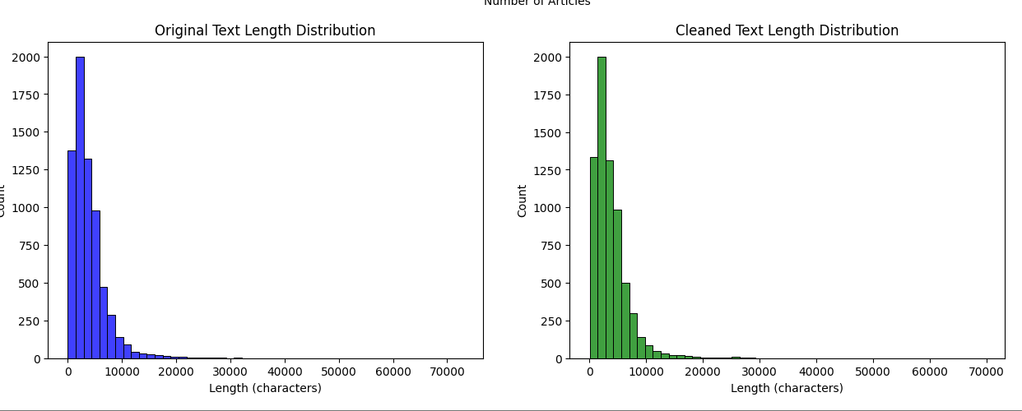

The balance of the dataset before the process of vectorization was also analyzed. The analysis in Figure 3 demonstrated that the category of Arts and Culture was far more common than any other category. This was an important observation, which resulted in the adoption of stratified sampling when splitting the training, in order to make sure that all categories were equally distributed.

Figure 3

Distribution of News Articles Per Category

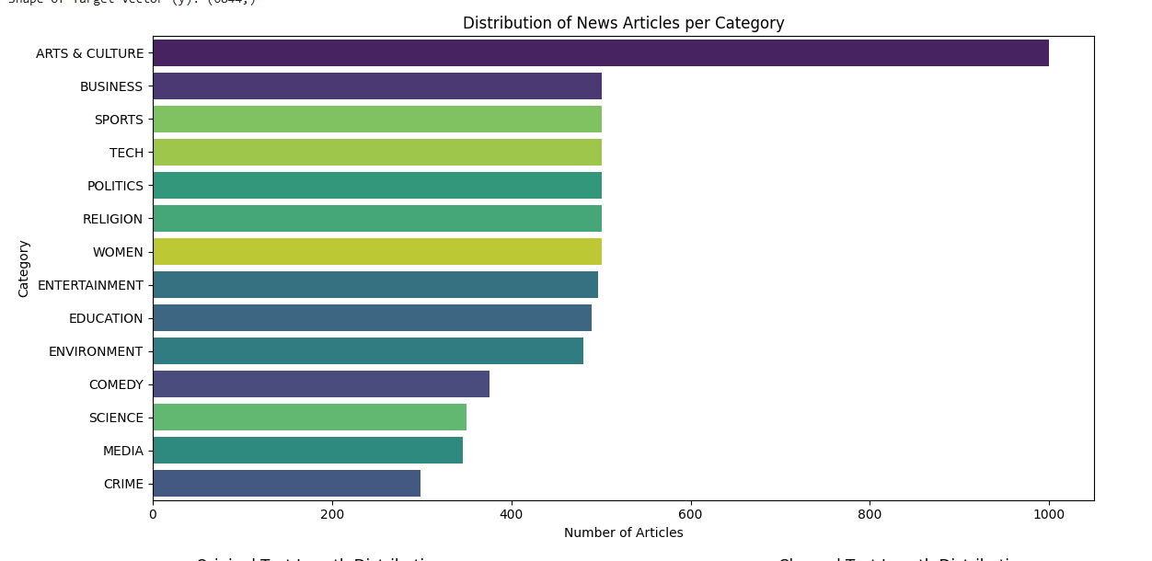
Feature Extraction

The Term Frequency-Inverse Document Frequency (TF-IDF) vectorization technique was used to convert raw textual data into numerical features, which is appropriate for the Support Vector Machine (SVM), as shown in Figure 4. By comparing a term’s frequency within a single document to its prevalence over the entire dataset, this will effectively eliminate common noise while highlighting unique keywords. The vectorizer was limited to a maximum of 5,000 characteristics in order to guarantee a simplified balance between processing speed and prediction complexity. With this particular setup, the model maintains great computational efficiency for real-time applications while prioritising the most instructive patterns within the news categories.

Figure 4

Data Transformation
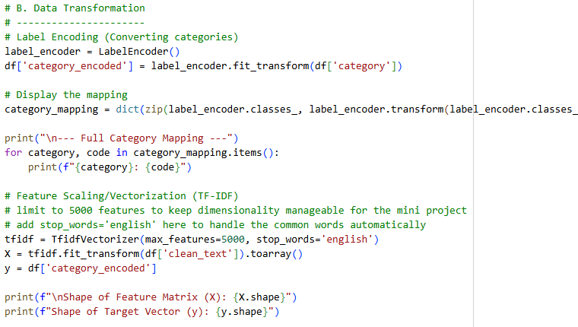

The Proposed Algorithm: Linear SVM

For the pattern recognition engine for text classification, a Linear Support Vector Machine (Linear SVM) was selected. SVM is the most suitable choice for text classification tasks because it is highly effective in high-dimensional spaces.

The training process follows the logic defined in the following equation:

f (x) = sign(w · x + b)

Where:

- f (x) is the predicted class label.
- w is the weight vector (what the model learns during training).
- x is the numerical features (TF-IDF weights) of the text.
- b is the bias term (a constant value).
- If f (x) > 0, it belongs to one category; if f (x) < 0, it belongs to another.

The model uses a regularization parameter C = 1.0 to help find a balance between having a clear boundary and making fewer mistakes. The data was divided into two groups, which are 80% and 20%. 80% of the data was used to train the model, and the remaining 20% was used for testing. This method, which has been applied here, is called stratified sampling to ensure that the percentage of each news category stays the same in both the training and testing sets.

Model Implementation and Pipeline

The system was built using a Scikit-learn Pipeline that combines both text-to-number process (TF-IDF) and the model (LinearSVM) into one single tool. This setup is important because it makes sure that any new text entered into the GUI is handled in exactly the same way as the data used during training. By bundling these steps together, the system can provide fast and reliable results for real-time news classification.
Algorithm 1: Training and Prediction Pipeline
- Input: Cleaned news dataset CSV.
- Split: Divide data into an 80/20 ratio, which is 80% for train and the remaining 20% for test.
- Vectorization: Apply TF-IDF to the training dataset to convert it into numerical.
- Fit: Train the Linear SVM model on the vectorized training data.
- Evaluate: Generate predictions on the testing dataset and calculate accuracy, precision, and F1-score.
- Deploy: Export the pipeline for real-time prediction in the Streamlit/Tkinter UI.

MODEL DEVELOPMENT

The Streamlit framework was used to develop a web-based User Interface (UI). This was done so that the practical application of the Liner Support Vector Machine (SVM) model can be demonstrated. Streamlit was selected for its ability to display and render a machine learning dashboard easily. It is also capable of handling real-time data without complex frontend requirements.

System Architecture

The prototype was split into three distinct modules; the first module is the data ingestion and training dashboard. This module allows the user to upload the raw .csv dataset to the system. The system integrates the preprocessing pipeline and the Linear SVM model directly into the application logic. Users can dynamically adjust the test-split ratio and initiate model training. Upon completion, the system renders the performance metrics and the confusion matrix.

The second model is the manual prediction model where an interactive text area where users can input custom news headlines. The trained model processes this input through the saved pipeline and returns the predicted category label.

The third model is the real-time stream simulation in which the system utilizes a feed simulator. This module iterates through a predefined list of incoming news streams, mimicking an API feed. The application updates the GUI dynamically every 1.5 seconds, displaying the incoming text, the predicted category, and a color-coded confidence indicator.

Figure 5

UI Prototype - Model Training Dashboard
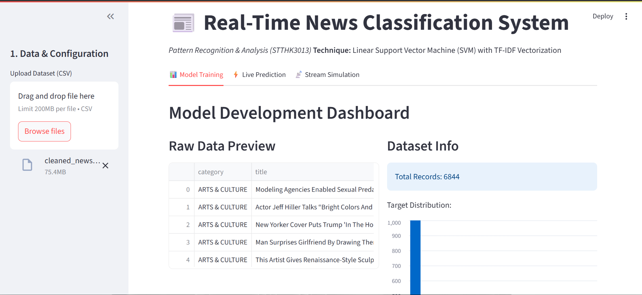
Figure 6

UI Prototype - Live Stream Simulation
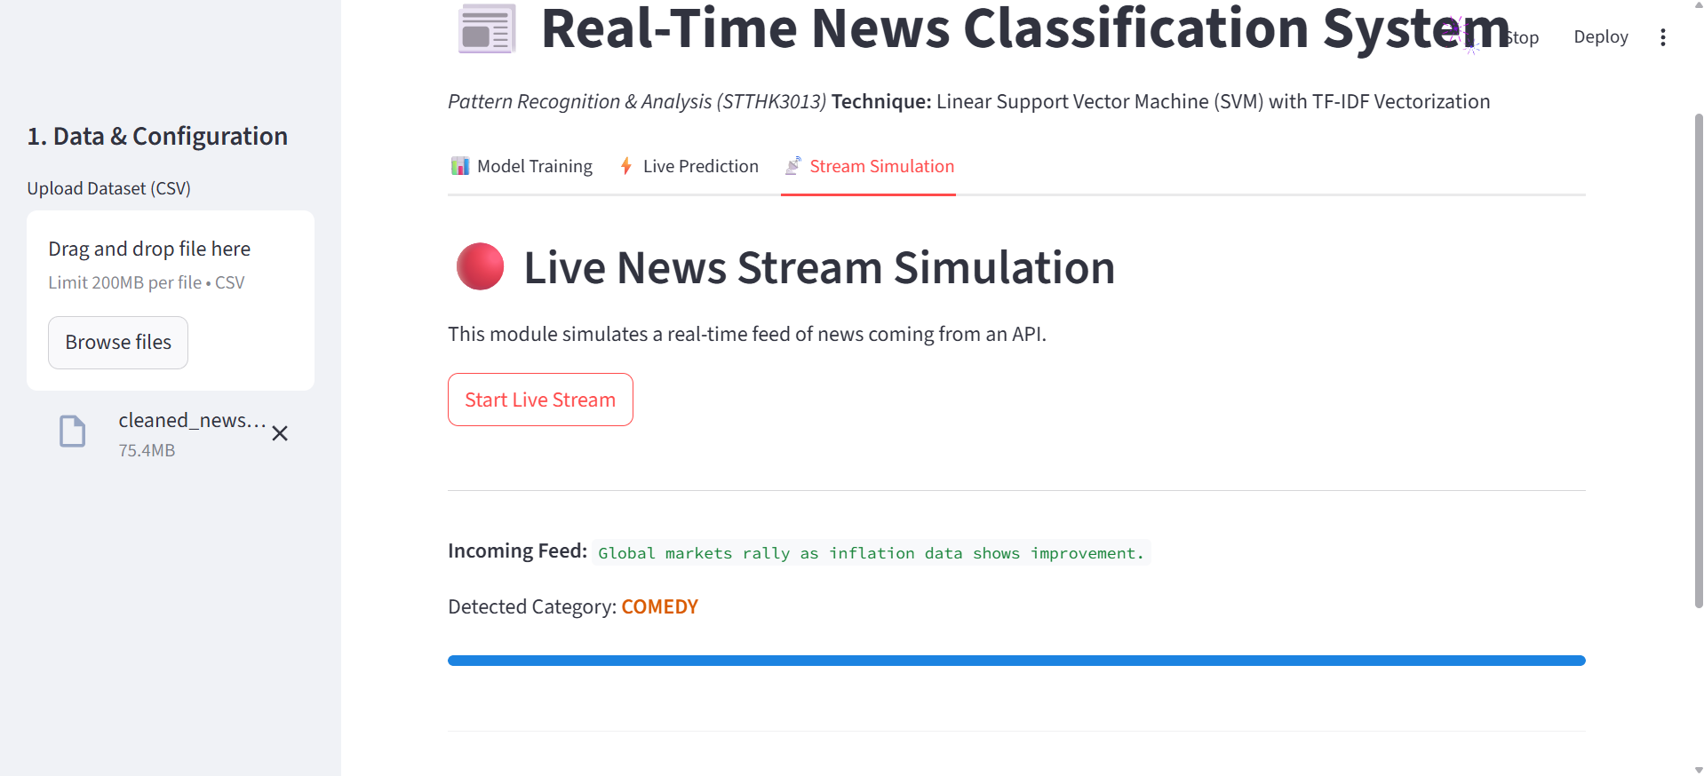

EVALUATION AND RESULTS

Quantitative Performance Analysis

The performance of the Linear Support Vector Machine (LinearSVM) was tested using a clear and systematic method. To ensure that the results are reliable, the dataset was split into two groups, which are 80% for training the model and 20% for testing its performance, resulting in a total of 1369 samples for testing. Four main metrics are used to measure the effectiveness of the pattern recognition. The four main metrics are precision, recall, f1-score, and accuracy. This approach can ensure a balanced and fair evaluation of the model’s ability to classify news data.

Table 1 shows the performance metrics for the proposed linear SVM model based on four main metrics.

Table 1

Performance Metrics for the Proposed Linear SVM Model

Metric | Result (Score) | Interpretation
Accuracy | 0.81 | Percentage of total correct news category predictions.
Precision (Weighted Avg) | 0.81 | Effectiveness in minimizing false positives across all categories.
Recall (Weighted Avg) | 0.81 | Sensitivity in identifying relevant instances within the dataset.
F1-Score (Weighted Avg) | 0.81 | Balanced performance metric representing stable classification.

From table 1, the model achieved an overall accuracy of 0.81, which means 81% of the news articles in the testing set were correctly categorized. Furthermore, the precision, recall, and F1-score all stabilized at 0.81. The balance across these three metrics is important as it proves the model is not biased toward a single category. Instead, the system shows a balanced ability to both correctly identify categories (Recall) and maintain high accuracy in predictions (Precision). These results confirm that the Linear SVM algorithm and TF-IDF vectorization serve as a reliable base for the real-time pattern recognition system.

Error Analysis and Insights

Figure 7 shows a detailed analysis that was conducted to identify the specific classification mistakes made by the algorithm.

Figure 7

Confusion Matrix: Linear SVM

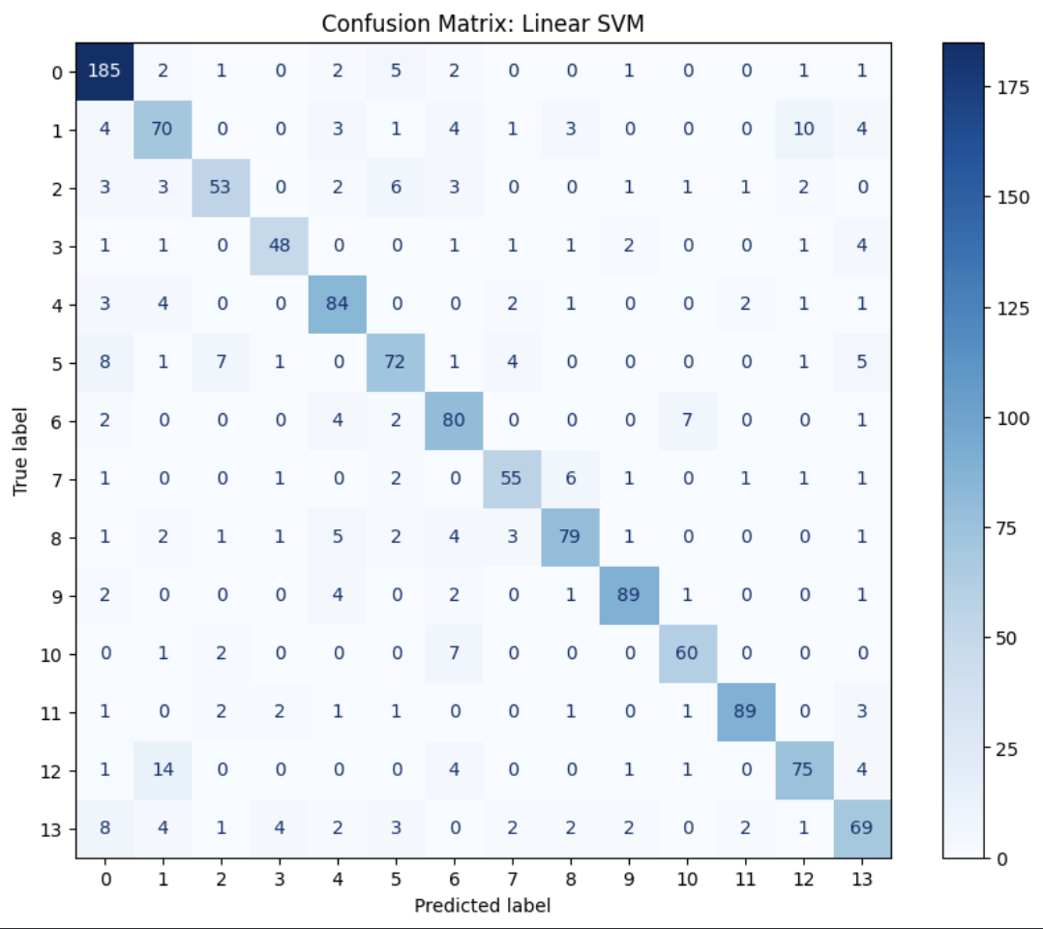

Figure 7, it shows that the system is highly effective at recognizing patterns. It can be known by looking at the dark blue diagonal line representing a high number of correct predictions across almost all 14 categories. Category 0 achieved the highest success with 185 correct classifications, followed by classes 9 and 11 with 89 correct predictions. The lowest is category 3 ,which has 48 correct predictions, but the overall consistency of the 0.81 metrics confirms that the model is balanced and reliable for real-time news classification.
CONCLUSION

In conclusion, the main objectives of this project have been achieved through the creation of an efficient Automated News Classification System that could be used to classify unstructured text with a high degree of reliability. The system attained a total accuracy of 80% on the testing data by employing a machine learning pipeline consisting of an extraction and a classification method based on Term Frequency-Inverse Document Frequency (TF-IDF) and Linear Support Vector Machine (Linear SVC), respectively. It confirms the hypothesis that, paired with effective text preprocessing strategies, namely concatenation of article headlines and body text, linear models are very useful in high-dimensional text classification tasks. It was found that the model was quite effective in classifying categories where whole lexicons are not similar, e.g., Arts & Culture and Sports, but predictably struggles in separating semantically similar areas such as Business and Politics, where vocabulary often overlaps.

Practically, the system is shown to be very useful to the digital media industry. The computational efficiency of the LinearSVC algorithm enables the processing of thousands of articles in a short time,e making this algorithm a scalable substitute to the information overload problem experienced by news aggregators and archivists. Nonetheless, some important ethical issues related to the bias of data were raised in the study as well. The skewness of the data was also heavy towards the Arts and Culture category, which had almost twice as many samples as other categories. Unaddressed in a real-world production setting, such as class imbalance, would cause an algorithmic bias, with the model showing a consistent biased preference towards the dominant category and potentially repressing or misclassifying minority issues. This highlights the need to have constant monitoring and data balancing methods, e.g., oversampling, so that the automated systems act as neutral and fair judges of the information rather than entrenching the existing differences in media coverage.

REFLECTION
The completion of this project was an important glimpse into the reality of data science, namely, that the data in the real-life is not often clean. The preprocessing phase consumed a significant amount of the project timeline since there was a need to resolve problems related to HTML artifacts, duplicate entries, and null values to make the model stable. It turned out that bypassing these so-called janitorial tasks, no matter how sophisticated the algorithm is bound to cause a low model performance. When approaching such a project, a second time around, we would be more aggressive in correcting the class imbalance that was present in the category of Arts and Culture through the use of oversampling. My personal recommendation to students studying in the future is to invest most of their time solving the raw data prior to writing any models, before making any modeling code,e because it is the most efficient way to avoid any mistakes and to have a strong classification system.

REFERENCES
Bird, S., Klein, E., & Loper, E. (2009). Natural language processing with Python. O'Reilly Media. https://www.nltk.org/book/
McKinney, W. (2010). Data structures for statistical computing in Python. In S. van der Walt & J. Millman (Eds.), Proceedings of the 9th Python in Science Conference (pp. 51–56). https://doi.org/10.25080/Majora-92bf1922-00a
Pedregosa, F., Varoquaux, G., Gramfort, A., Michel, V., Thirion, B., Grisel, O., Blondel, M., Prettenhofer, P., Weiss, R., Dubourg, V., Vanderplas, J., Passos, A., Cournapeau, D., Brucher, M., Perrot, M., & Duchesnay, E. (2011). Scikit-learn: Machine learning in Python. Journal of Machine Learning Research, 12, 2825–2830. https://jmlr.csail.mit.edu/papers/v12/pedregosa11a.html
Sammut, C., & Webb, G. I. (Eds.). (2010). Encyclopedia of machine learning. Springer Science & Business Media. https://doi.org/10.1007/978-0-387-30164-8
Timilsina, B. (2021). News article categories dataset. Kaggle. https://www.kaggle.com/datasets/timilsinabimal/newsarticlecategories

